TEACHER EVALUATION

The Maysville Board of Education believes that personnel evaluation is a mutual endeavor among all staff d the board to improve the quality of the overall educational program. The improvement of the district's educational efforts must be a joint responsibility of the school district and the individual educator.

All certified staff members shall be evaluated using an evaluation system that has been approved by the Oklahoma State Board of Education. The completed evaluation shall be retained in the personnel file of the person being evaluated. The evaluation instrument is a confidential document and shall be protected accordingly.

Probationary teachers shall receive formative feedback from the evaluation process at least twice each year. Formative feedback shall occur during the fall semester, and at least once during the spring semester, each year. Career teachers shall be evaluated at least once each year except for career teachers receiving a qualitative and quantitative "superior" or "highly effective" rating under the TLE, who may be evaluated once every three (3) years. Evaluations of teachers shall be made by the appropriate certified principal, or other designated certified and qualified administrative person.

During the 2015-2016 school year, school districts shall for the purposes of establishing baseline data incorporate quantitative components of the TLE into the evaluations used in all school sites within the district. The evaluation rating of teachers and administrators shall be based on the qualitative component of the TLE. A school district with an average daily attendance of more than thirty-five thousand (35,000) may incorporate at its own expense the quantitative components of the TLE into its evaluation system of teachers and administrators as defined by the school district's written policy.

The evaluation shall be reviewed by the staff member and the evaluator. Either or both may attach written and signed comments to the evaluation instrument within two weeks of the evaluation, provided that no additional statements or comments shall be attached without the teacher's knowledge. The teacher's signature on the evaluation instrument shall serve only to reflect the teacher's acknowledgment that an evaluation was conducted. A copy of the completed evaluation instrument will be provided to the teacher.

Except by order of a court of competent jurisdiction, evaluation documents and the responses thereto shall be made available only to the evaluated person, the board of education, the administrative staff making the evaluation, the board and administrative staff of any school to which the evaluated person applies for employment, and such other persons given consent by the teacher in writing, and shall be subject to disclosure at a hearing or trial de nova.

If the evaluation discloses any area(s) in which improvement can be reasonably expected and desired, the principal shall discuss such area(s) with the teacher and offer suggestions and recommendations as to how improvement may be achieved. Such recommendations shall be recorded on the evaluation instrument.

When the evaluating administrator identifies poor performance or conduct that the administrator believes may lead to a recommendation for the career teacher's dismissal or nonreemployment, the administrator will admonish the teacher in writing and make reasonable effort to assist the teacher in correcting the poor performance or conduct; and establish a reasonable time for improvement, not to exceed two months.

TEACHER EVALUATION (Cont.)

If the career teacher does not correct the poor performance or conduct cited in the admonition within the time specified, the administrator shall make a recommendation to the superintendent for the dismissal or nonreemployment of the teacher. A probationary teacher will receive a plan of improvement if inadequate teaching performance exists.

The board shall review this evaluation policy on an annual basis following consultation or involvement by representatives selected by the teachers in this district.

REFERENCE: 70 0.5. §6-101.10, et seq.

THIS POLICY REQUIRED BY LAW.

TEACHER EVALUATION (Cont.)

ANNUAL REVIEW

Date of Review | Signature
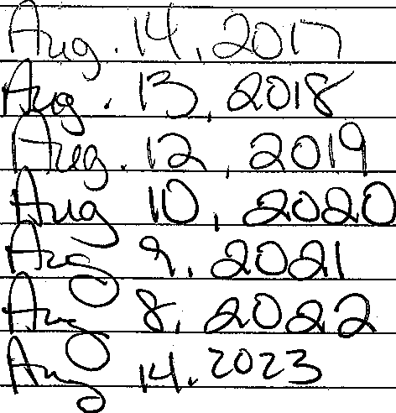 | 